1. **Agenda**:
   1. How to Stub.
2. **Gradle Dependency**:

**Maven Dependency** 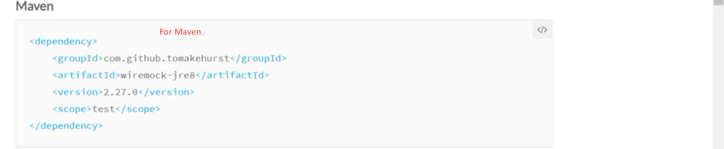

1. 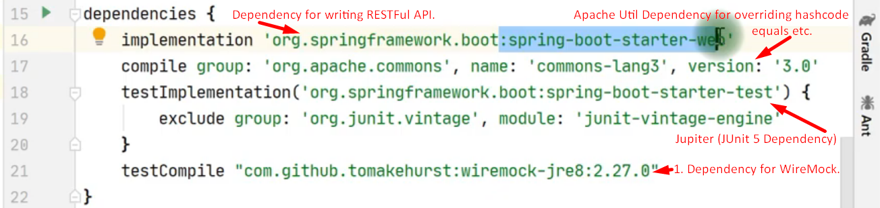
2. **Let’s first configure and run WireMock Server**.
   1. 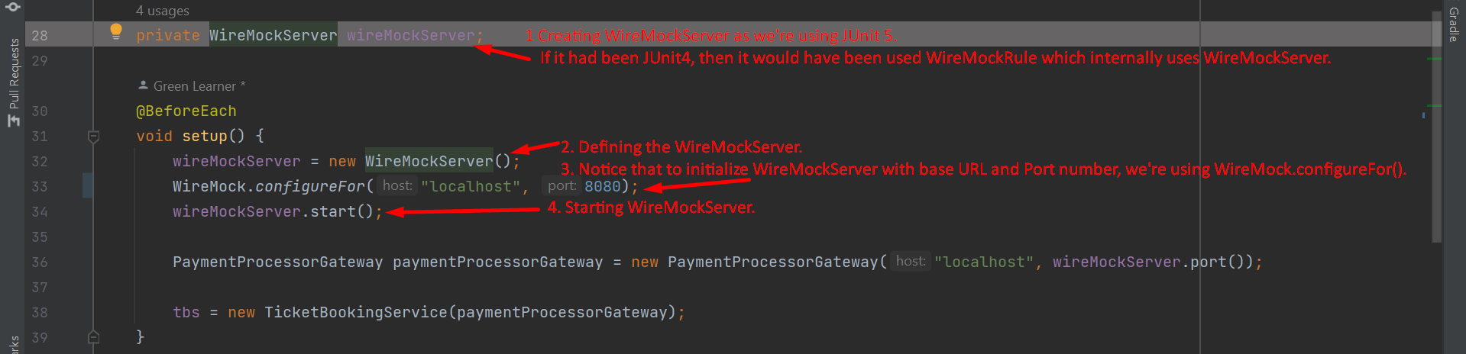
3. **Very General Stubbing**:  
   
4. **Stubbing for POST and Exact URL Path & With a specific request body (JSON) and returning a specific response (JSON)  
   In the below slide, we forgot to put Comma in JSON Data.**A picture containing chart

   Description automatically generated
5. **Let’s see how to do multiple stubbing for same test case.**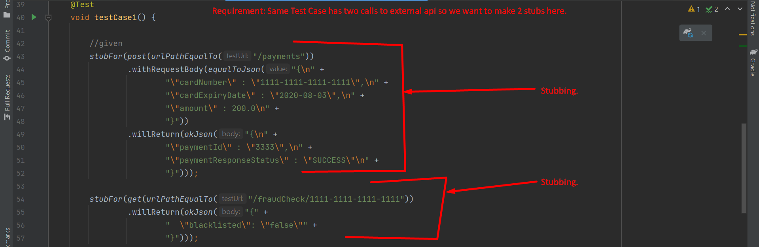
6. **Requirement: When sure about received JSON’s attributes but not about their values, then use matchingJsonPath(…) instead of equalToJson(…)**  
   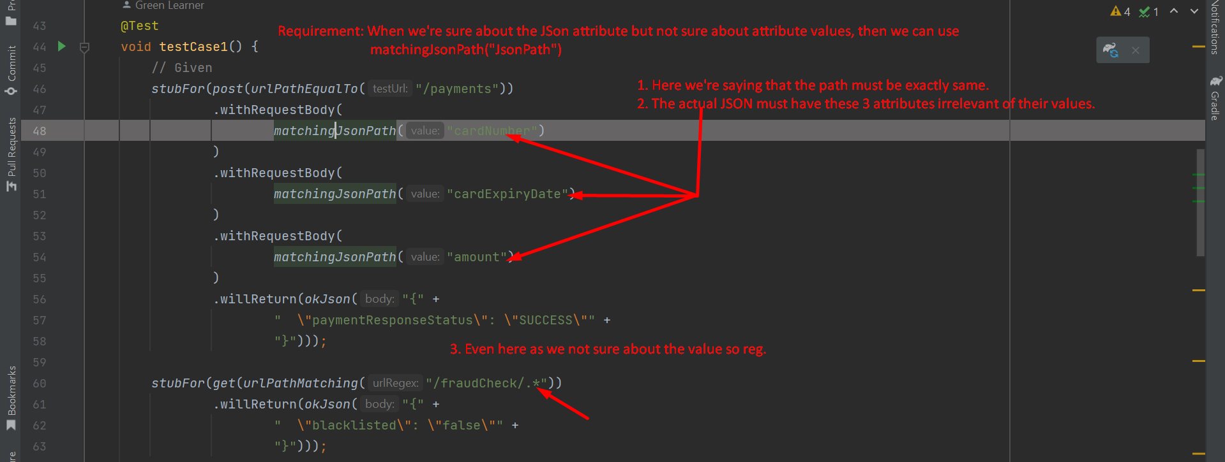
7. **Requirement**: **What if we have two stubs for the same exact request body, then which one will have precedence**?  
   **Answer**: By default, the last one stubbed will have more precedence.   
   **Question**: **How to set the priority**?  
   **Answer**: Calling atPriority(int). The lowest number is the highest priority.  
   